**WEEK 4**

**Spring REST using Spring Boot 3**

**Hands on 1**

**Create a Spring Web Project using Maven**

**SpringLearnApplication.java:**

package com.cognizant.springlearn;

import org.springframework.boot.SpringApplication;

import org.springframework.boot.autoconfigure.SpringBootApplication;

@SpringBootApplication

public class SpringLearnApplication {

public static void main(String[] args) {

System.out.println("Application Starting...");

SpringApplication.run(SpringLearnApplication.class, args);

System.out.println("Application Started.");

}

}

**pom.xml:**

<?xml version="1.0" encoding="UTF-8"?>

<project xmlns="http://maven.apache.org/POM/4.0.0" xmlns:xsi="http://www.w3.org/2001/XMLSchema-instance"

xsi:schemaLocation="http://maven.apache.org/POM/4.0.0 https://maven.apache.org/xsd/maven-4.0.0.xsd">

<modelVersion>4.0.0</modelVersion>

<parent>

<groupId>org.springframework.boot</groupId>

<artifactId>spring-boot-starter-parent</artifactId>

<version>3.5.3</version>

<relativePath/> <!-- lookup parent from repository -->

</parent>

<groupId>com.cognizant</groupId>

<artifactId>spring-learn</artifactId>

<version>0.0.1-SNAPSHOT</version>

<name>spring-learn</name>

<description>Demo project for Spring Boot</description>

<url/>

<licenses>

<license/>

</licenses>

<developers>

<developer/>

</developers>

<scm>

<connection/>

<developerConnection/>

<tag/>

<url/>

</scm>

<properties>

<java.version>17</java.version>

</properties>

<dependencies>

<dependency>

<groupId>org.springframework.boot</groupId>

<artifactId>spring-boot-starter-web</artifactId>

</dependency>

<dependency>

<groupId>org.springframework.boot</groupId>

<artifactId>spring-boot-devtools</artifactId>

<scope>runtime</scope>

<optional>true</optional>

</dependency>

<dependency>

<groupId>org.springframework.boot</groupId>

<artifactId>spring-boot-starter-test</artifactId>

<scope>test</scope>

</dependency>

</dependencies>

<build>

<plugins>

<plugin>

<groupId>org.springframework.boot</groupId>

<artifactId>spring-boot-maven-plugin</artifactId>

</plugin>

</plugins>

</build>

</project>

**Output:**

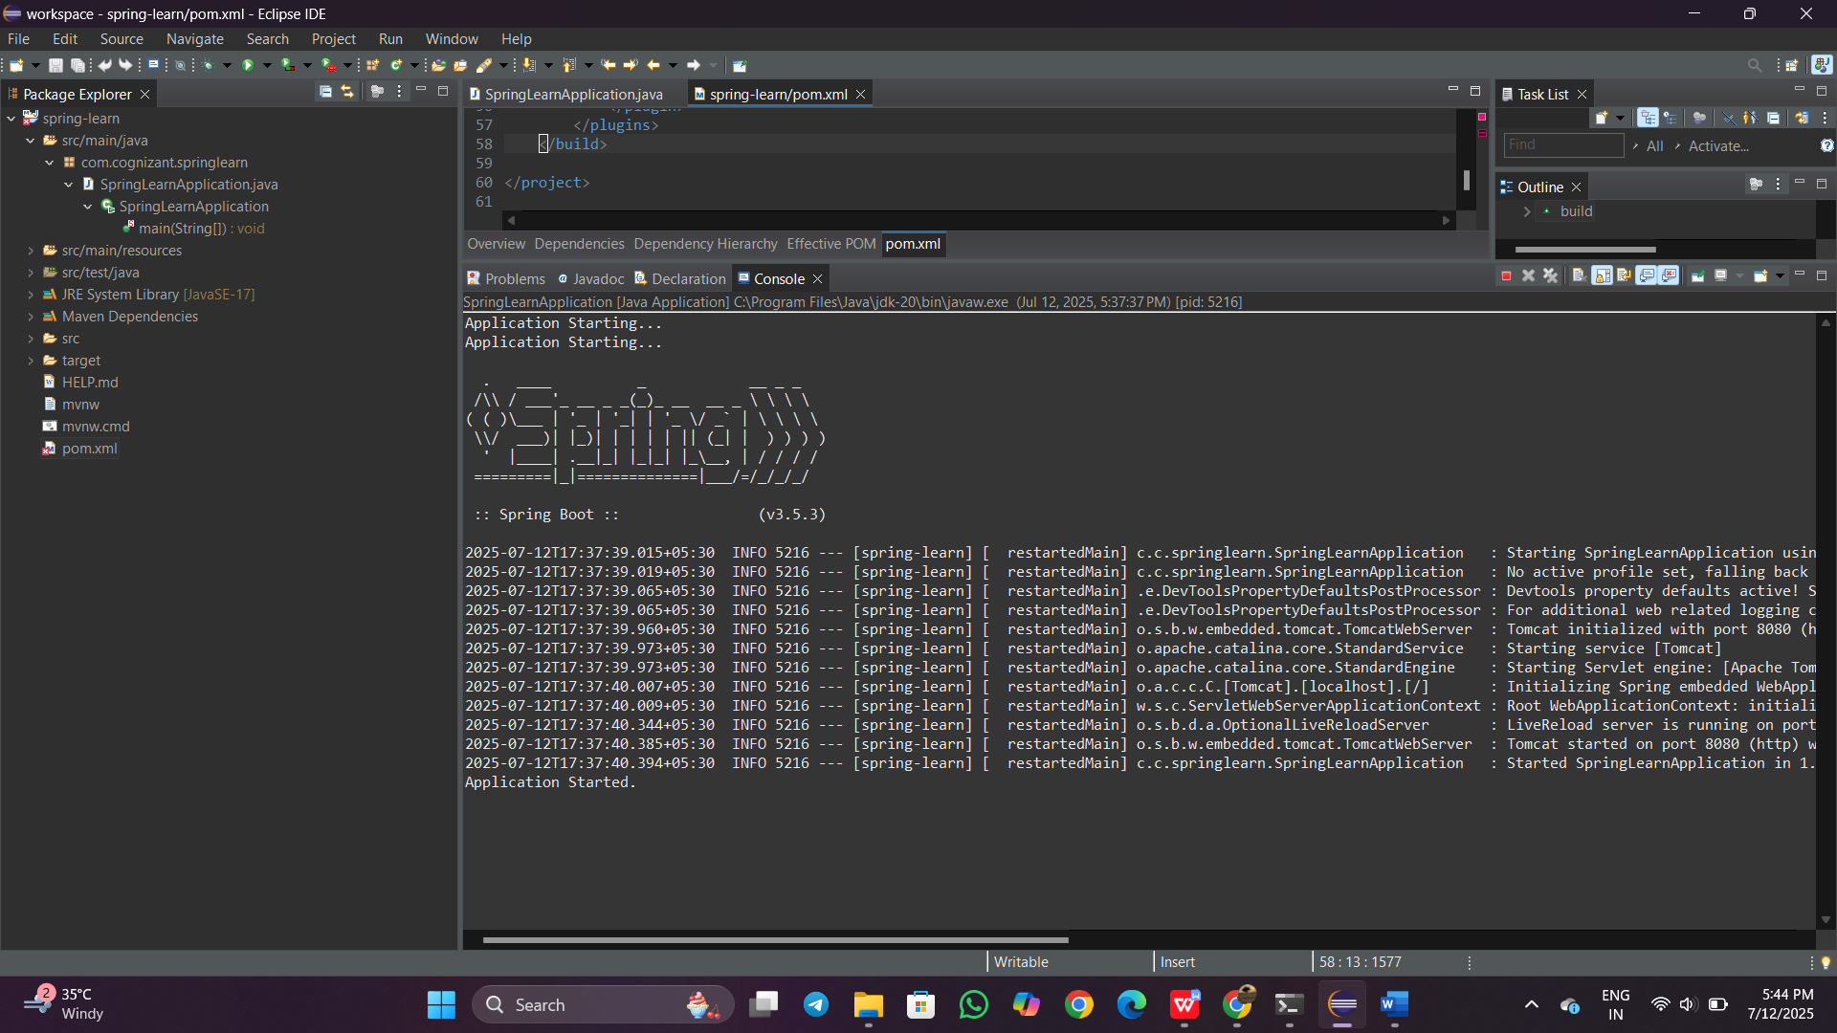

**Hands on 4**

**Spring Core – Load Country from Spring Configuration XML**

**Country.java**

package com.cognizant.springlearn;

import org.slf4j.Logger;

import org.slf4j.LoggerFactory;

public class Country {

private String code;

private String name;

private static final Logger LOGGER = LoggerFactory.getLogger(Country.class);

public Country() {

LOGGER.debug("Inside Country Constructor.");

}

public String getCode() {

LOGGER.debug("Getting code: {}", code);

return code;

}

public void setCode(String code) {

LOGGER.debug("Setting code: {}", code);

this.code = code;

}

public String getName() {

LOGGER.debug("Getting name: {}", name);

return name;

}

public void setName(String name) {

LOGGER.debug("Setting name: {}", name);

this.name = name;

}

@Override

public String toString() {

return "Country [code=" + code + ", name=" + name + "]";

}

}

**Country.xml**

<?xml version="1.0" encoding="UTF-8"?>

<beans xmlns="http://www.springframework.org/schema/beans"

xmlns:xsi="http://www.w3.org/2001/XMLSchema-instance"

xsi:schemaLocation="http://www.springframework.org/schema/beans

https://www.springframework.org/schema/beans/spring-beans.xsd">

<bean id="country" class="com.cognizant.springlearn.Country">

<property name="code" value="IN" />

<property name="name" value="India" />

</bean>

</beans>

**SpringLearnApplication.java**

package com.cognizant.springlearn;

import org.slf4j.Logger;

import org.slf4j.LoggerFactory;

import org.springframework.context.ApplicationContext;

import org.springframework.context.support.ClassPathXmlApplicationContext;

public class SpringLearnApplication {

private static final Logger LOGGER = LoggerFactory.getLogger(SpringLearnApplication.class);

public static void main(String[] args) {

LOGGER.info("START");

displayCountry();

LOGGER.info("END");

}

public static void displayCountry() {

ApplicationContext context = new ClassPathXmlApplicationContext("country.xml");

Country country = context.getBean("country", Country.class);

LOGGER.debug("Country : {}", country.toString());

}

}

**Output:**

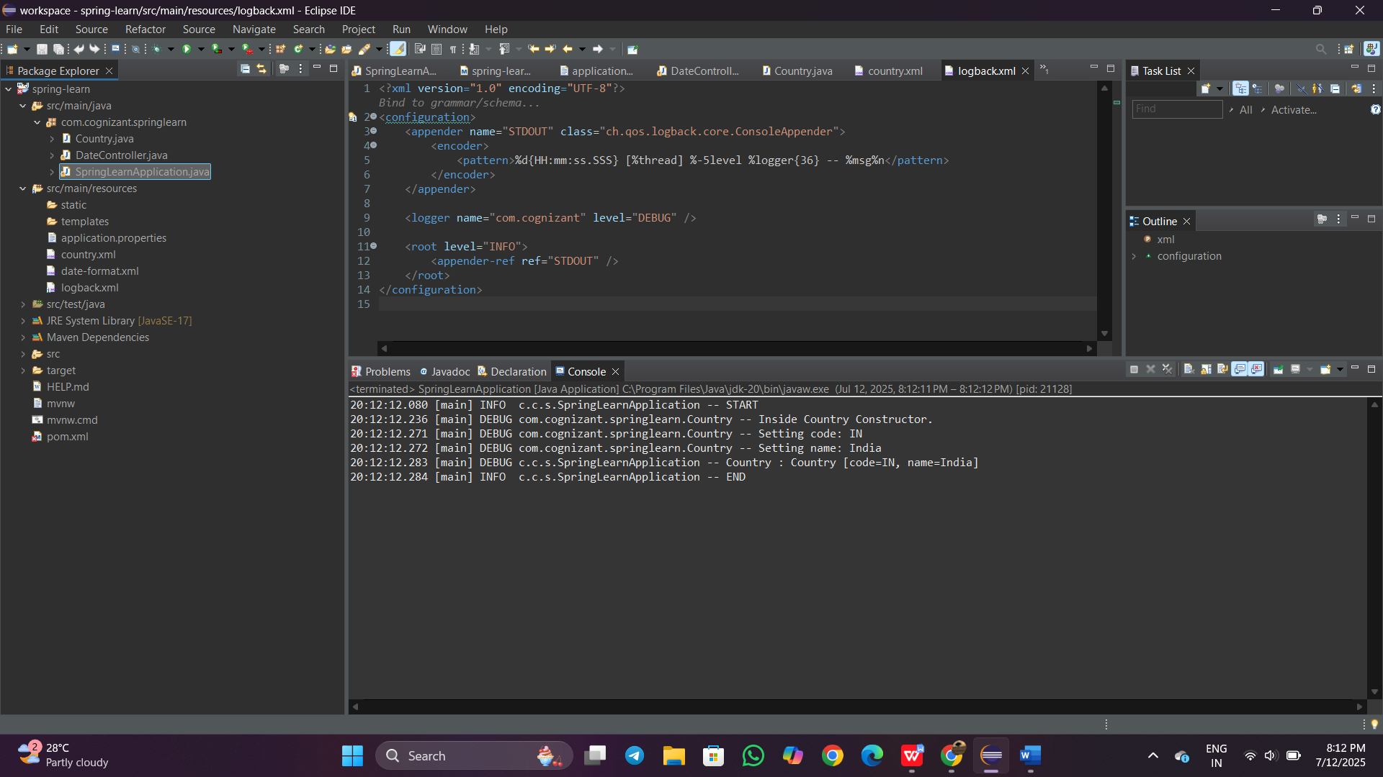

**Hello World RESTful Web Service**

**src/main/resources/application.properties**

server.port=8083

**HelloController.java**

package com.cognizant.springlearn.controller;

import org.slf4j.Logger;

import org.slf4j.LoggerFactory;

import org.springframework.web.bind.annotation.GetMapping;

import org.springframework.web.bind.annotation.RestController;

@RestController

public class HelloController {

private static final Logger LOGGER = LoggerFactory.getLogger(HelloController.class);

@GetMapping("/hello")

public String sayHello() {

LOGGER.info("Start sayHello()");

String message = "Hello World!!";

LOGGER.info("End sayHello()");

return message;

}

}

**SpringLearnApplication.java**

package com.cognizant.springlearn;

import org.springframework.boot.SpringApplication;

import org.springframework.boot.autoconfigure.SpringBootApplication;

@SpringBootApplication

public class SpringLearnApplication {

public static void main(String[] args) {

SpringApplication.run(SpringLearnApplication.class, args);

}

}

Output:

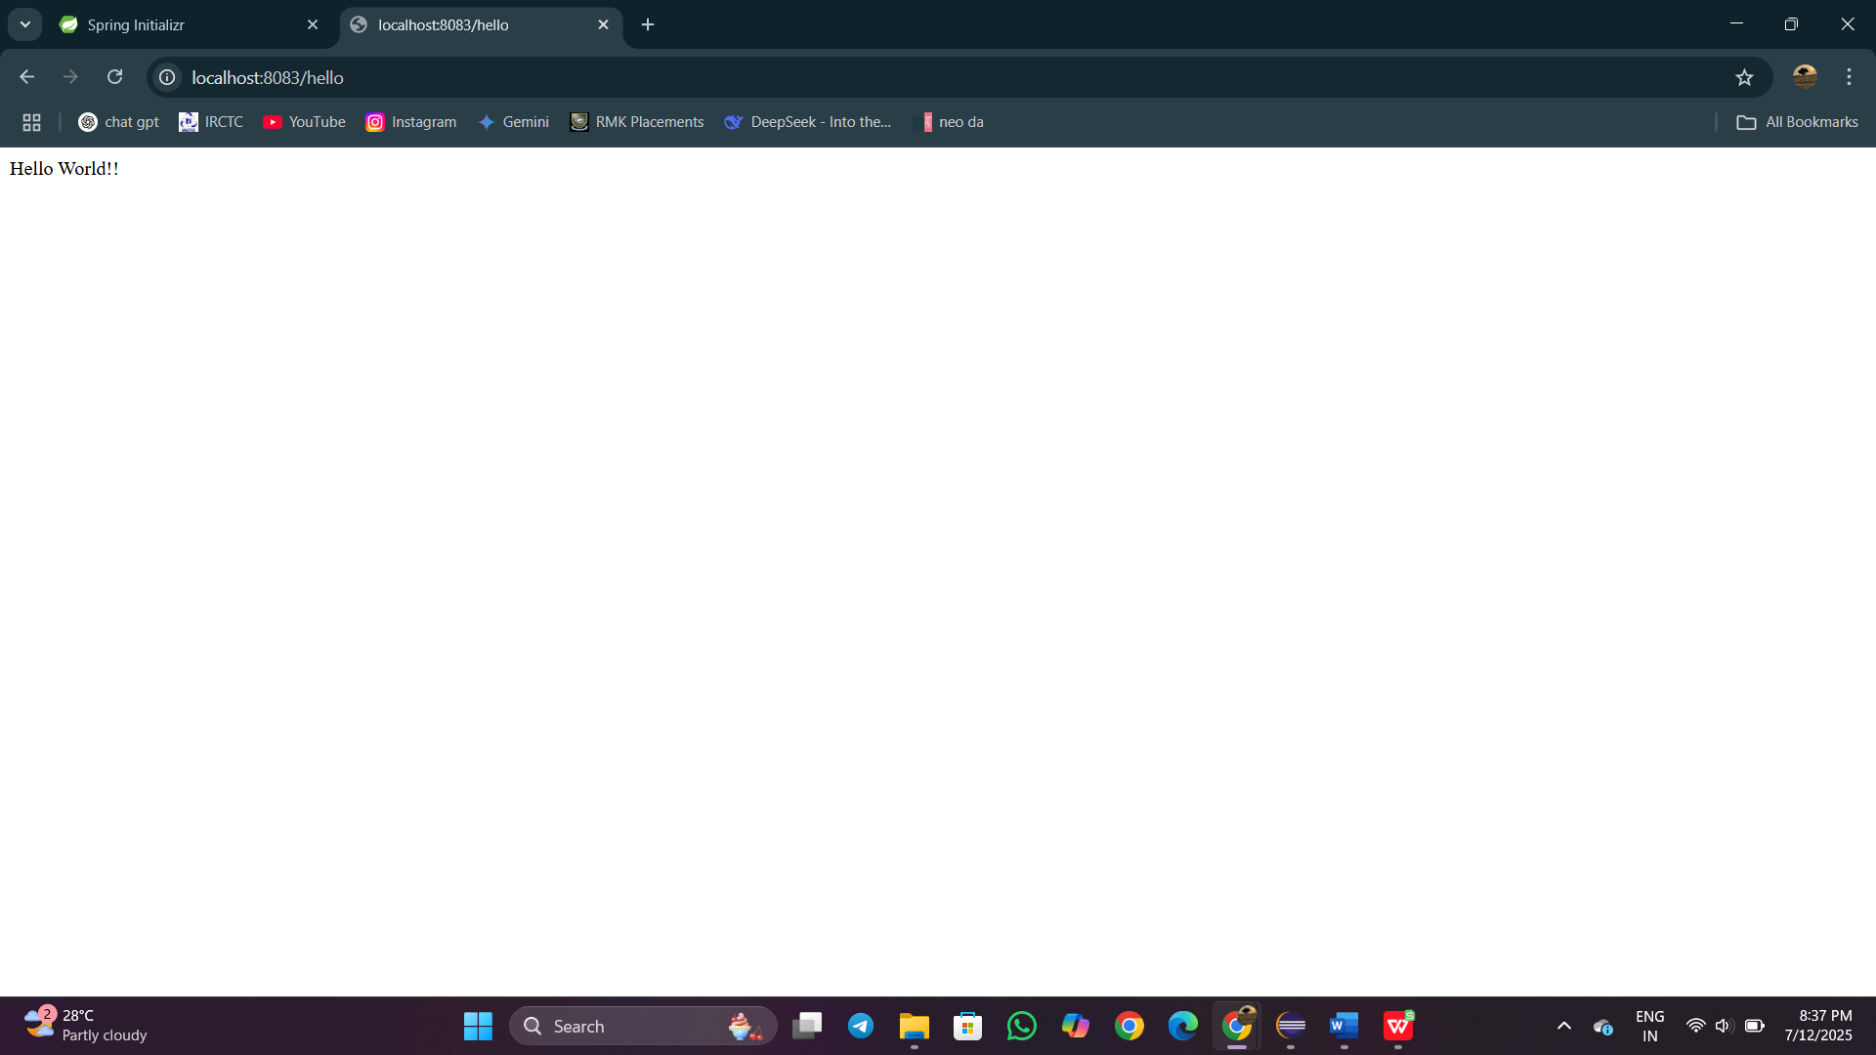

**REST - Get country based on country code**

**Country.java**

package com.cognizant.springlearn;

public class Country {

private String code;

private String name;

public Country() {}

public String getCode() {

return code;

}

public void setCode(String code) {

this.code = code;

}

public String getName() {

return name;

}

public void setName(String name) {

this.name = name;

}

@Override

public String toString() {

return "Country [code=" + code + ", name=" + name + "]";

}

}

Country.xml

<?xml version="1.0" encoding="UTF-8"?>

<beans xmlns="http://www.springframework.org/schema/beans"

xmlns:xsi="http://www.w3.org/2001/XMLSchema-instance"

xsi:schemaLocation="http://www.springframework.org/schema/beans

https://www.springframework.org/schema/beans/spring-beans.xsd">

<bean id="countryList" class="java.util.ArrayList">

<constructor-arg>

<list>

<bean class="com.cognizant.springlearn.Country">

<property name="code" value="IN"/>

<property name="name" value="India"/>

</bean>

<bean class="com.cognizant.springlearn.Country">

<property name="code" value="US"/>

<property name="name" value="United States"/>

</bean>

<bean class="com.cognizant.springlearn.Country">

<property name="code" value="JP"/>

<property name="name" value="Japan"/>

</bean>

<bean class="com.cognizant.springlearn.Country">

<property name="code" value="DE"/>

<property name="name" value="Germany"/>

</bean>

</list>

</constructor-arg>

</bean>

</beans>

**CountryService.java:**

package com.cognizant.springlearn.service;

import com.cognizant.springlearn.Country;

import org.springframework.context.ApplicationContext;

import org.springframework.context.support.ClassPathXmlApplicationContext;

import org.springframework.stereotype.Service;

import java.util.List;

@Service

public class CountryService {

public Country getCountry(String code) {

ApplicationContext context = new ClassPathXmlApplicationContext("country.xml");

List<Country> countryList = (List<Country>) context.getBean("countryList");

return countryList.stream()

.filter(c -> c.getCode().equalsIgnoreCase(code))

.findFirst()

.orElse(null);

}

}

**CountryController.java:**

package com.cognizant.springlearn.controller;

import com.cognizant.springlearn.Country;

import com.cognizant.springlearn.service.CountryService;

import org.slf4j.Logger;

import org.slf4j.LoggerFactory;

import org.springframework.beans.factory.annotation.Autowired;

import org.springframework.web.bind.annotation.*;

@RestController

public class CountryController {

private static final Logger LOGGER = LoggerFactory.getLogger(CountryController.class);

@Autowired

private CountryService countryService;

@GetMapping("/countries/{code}")

public Country getCountry(@PathVariable String code) {

LOGGER.info("Start getCountry()");

Country country = countryService.getCountry(code);

LOGGER.info("End getCountry()");

return country;

}

}

**SpringLearnApplication.java**

package com.cognizant.springlearn;

import org.springframework.boot.SpringApplication;

import org.springframework.boot.autoconfigure.SpringBootApplication;

@SpringBootApplication

public class SpringLearnApplication {

public static void main(String[] args) {

SpringApplication.run(SpringLearnApplication.class, args);

}

}

**application.properties:**

application.properties

**Output:**

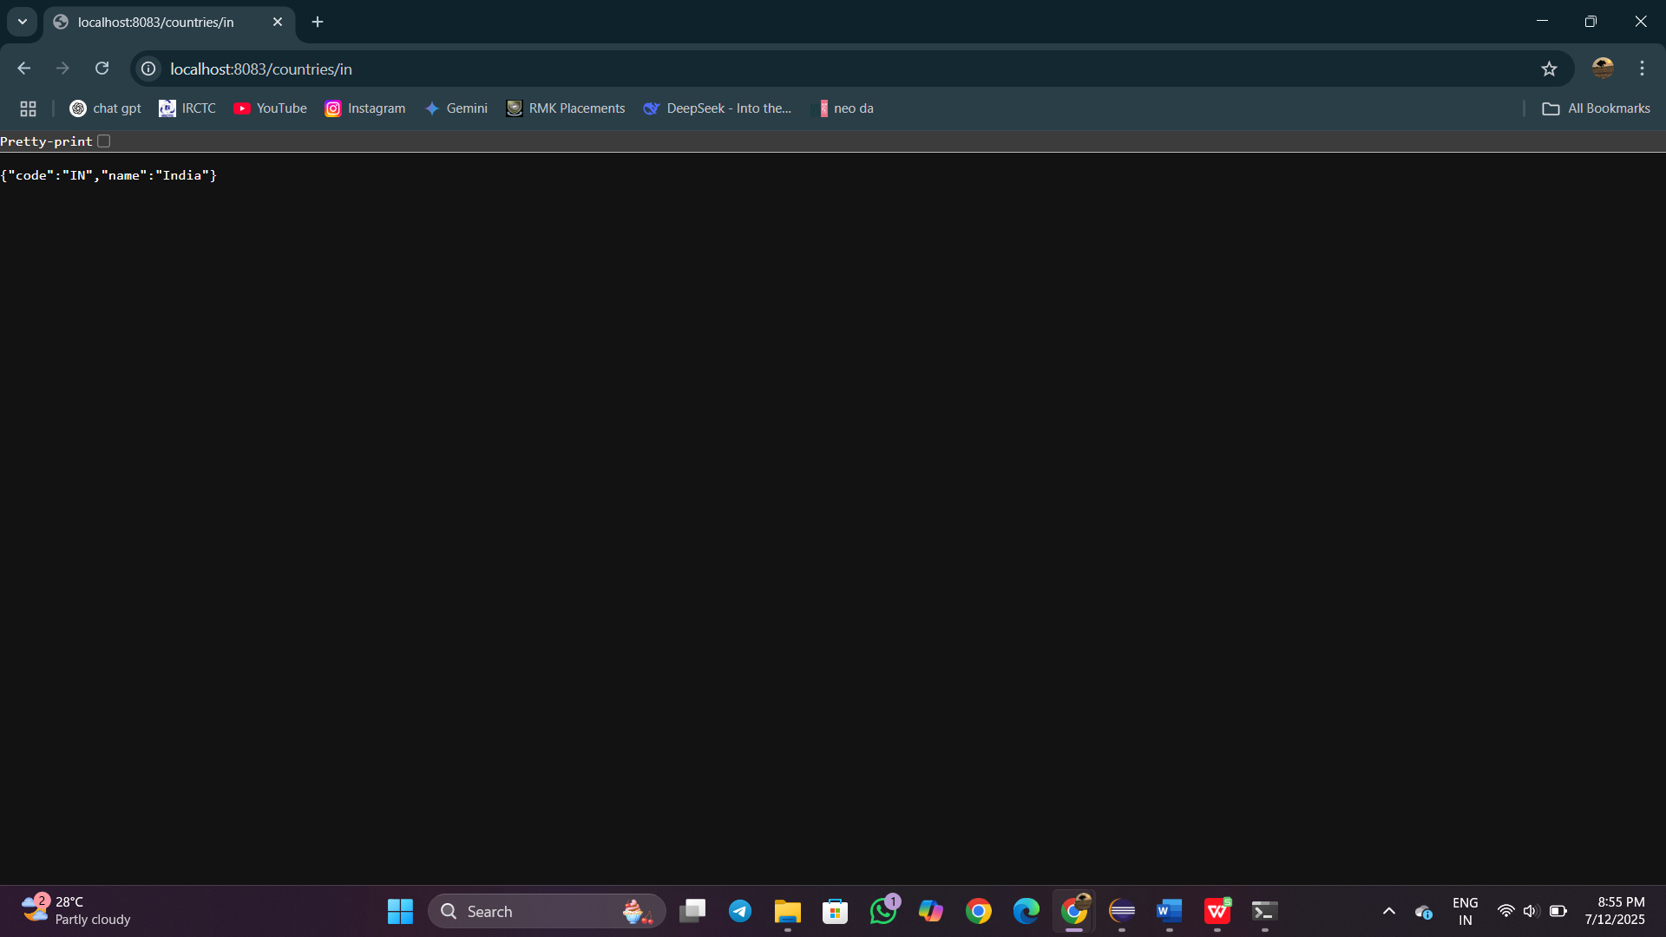

**Create authentication service that returns JWT**

**SecurityConfig.java**

package com.cognizant.springlearn.config;

import org.springframework.context.annotation.Bean;

import org.springframework.context.annotation.Configuration;

import org.springframework.security.authentication.AuthenticationManager;

import org.springframework.security.config.annotation.authentication.configuration.AuthenticationConfiguration;

import org.springframework.security.core.userdetails.User;

import org.springframework.security.core.userdetails.UserDetailsService;

import org.springframework.security.provisioning.InMemoryUserDetailsManager;

import org.springframework.security.web.SecurityFilterChain;

import org.springframework.security.config.annotation.web.builders.HttpSecurity;

*@Configuration*

public class SecurityConfig {

*@Bean*

public UserDetailsService userDetailsService() {

return new InMemoryUserDetailsManager(

User.*withUsername*("user")

.password("{noop}pwd") // {noop} disables encoding for dev/testing

.roles("USER")

.build()

);

}

*@Bean*

public AuthenticationManager authManager(AuthenticationConfiguration config) throws Exception {

return config.getAuthenticationManager();

}

*@Bean*

public SecurityFilterChain filterChain(HttpSecurity http) throws Exception {

http

.csrf(csrf -> csrf.disable())

.authorizeHttpRequests(auth -> auth

.requestMatchers("/authenticate").permitAll()

.anyRequest().authenticated()

)

.httpBasic(httpBasic -> {}); // ✅ correct usage without deprecation

return http.build();

}

}

**AuthController.java**

package com.cognizant.springlearn.controller;

import com.cognizant.springlearn.util.JwtUtil;

import org.springframework.beans.factory.annotation.Autowired;

import org.springframework.security.authentication.AuthenticationManager;

import org.springframework.security.authentication.UsernamePasswordAuthenticationToken;

import org.springframework.security.core.Authentication;

import org.springframework.web.bind.annotation.GetMapping;

import org.springframework.web.bind.annotation.RestController;

import java.util.Base64;

import java.util.HashMap;

import java.util.Map;

import jakarta.servlet.http.HttpServletRequest;

*@RestController*

public class AuthController {

*@Autowired*

private AuthenticationManager authManager;

*@Autowired*

private JwtUtil jwtUtil;

*@GetMapping*("/authenticate")

public Map<String, String> authenticate(HttpServletRequest request) {

String authHeader = request.getHeader("Authorization");

if (authHeader == null || !authHeader.startsWith("Basic ")) {

throw new RuntimeException("Missing or invalid Authorization header.");

}

String base64Credentials = authHeader.substring("Basic ".length());

byte[] decodedBytes = Base64.*getDecoder*().decode(base64Credentials);

String[] credentials = new String(decodedBytes).split(":", 2);

String username = credentials[0];

String password = credentials[1];

Authentication auth = authManager.authenticate(

new UsernamePasswordAuthenticationToken(username, password)

);

String token = jwtUtil.generateToken(username);

Map<String, String> response = new HashMap<>();

response.put("token", token);

return response;

}

}

**JwtUtil.java**

package com.cognizant.springlearn.util;

import io.jsonwebtoken.Jwts;

import io.jsonwebtoken.SignatureAlgorithm;

import org.springframework.stereotype.Component;

import java.util.Date;

*@Component*

public class JwtUtil {

private final String secret = "mysecretkey"; // In real use, keep it in env

public String generateToken(String username) {

return Jwts.*builder*()

.setSubject(username)

.setIssuedAt(new Date(System.*currentTimeMillis*()))

.setExpiration(new Date(System.*currentTimeMillis*() + 1000 * 60 * 60)) // 1 hour

.signWith(*SignatureAlgorithm*.***HS256***, secret)

.compact();

}

}

**SpringLearnApplication.java**

package com.cognizant.springlearn;

import org.springframework.boot.SpringApplication;

import org.springframework.boot.autoconfigure.SpringBootApplication;

*@SpringBootApplication*

public class SpringLearnApplication {

public static void main(String[] args) {

SpringApplication.*run*(SpringLearnApplication.class, args);

}

}

**Pom.xml**

<?xml version="1.0" encoding="UTF-8"?>

<project xmlns="http://maven.apache.org/POM/4.0.0" xmlns:xsi="http://www.w3.org/2001/XMLSchema-instance"

xsi:schemaLocation="http://maven.apache.org/POM/4.0.0 https://maven.apache.org/xsd/maven-4.0.0.xsd">

<modelVersion>4.0.0</modelVersion>

<parent>

<groupId>org.springframework.boot</groupId>

<artifactId>spring-boot-starter-parent</artifactId>

<version>3.5.3</version>

<relativePath/> <!-- lookup parent from repository -->

</parent>

<groupId>com.cognizant</groupId>

<artifactId>spring-learn</artifactId>

<version>0.0.1-SNAPSHOT</version>

<name>spring-learn</name>

<description>Demo project for Spring Boot</description>

<url/>

<licenses>

<license/>

</licenses>

<developers>

<developer/>

</developers>

<scm>

<connection/>

<developerConnection/>

<tag/>

<url/>

</scm>

<properties>

<java.version>17</java.version>

</properties>

<dependencies>

<dependency>

<groupId>org.springframework.boot</groupId>

<artifactId>spring-boot-starter-web</artifactId>

</dependency>

<!-- Spring Boot Starter Security -->

<dependency>

<groupId>org.springframework.boot</groupId>

<artifactId>spring-boot-starter-security</artifactId>

</dependency>

<!-- JWT -->

<dependency>

<groupId>io.jsonwebtoken</groupId>

<artifactId>jjwt</artifactId>

<version>0.9.1</version>

</dependency>

<!-- Logging -->

<dependency>

<groupId>org.springframework.boot</groupId>

<artifactId>spring-boot-starter-logging</artifactId>

</dependency>

<dependency>

<groupId>io.jsonwebtoken</groupId>

<artifactId>jjwt-api</artifactId>

<version>0.11.5</version>

</dependency>

<dependency>

<groupId>io.jsonwebtoken</groupId>

<artifactId>jjwt-impl</artifactId>

<version>0.11.5</version>

<scope>runtime</scope>

</dependency>

<dependency>

<groupId>io.jsonwebtoken</groupId>

<artifactId>jjwt-jackson</artifactId>

<version>0.11.5</version>

<scope>runtime</scope>

</dependency>

<dependency>

<groupId>javax.xml.bind</groupId>

<artifactId>jaxb-api</artifactId>

<version>2.3.1</version>

</dependency>

<dependency>

<groupId>org.springframework.boot</groupId>

<artifactId>spring-boot-devtools</artifactId>

<scope>runtime</scope>

<optional>true</optional>

</dependency>

<dependency>

<groupId>org.springframework.boot</groupId>

<artifactId>spring-boot-starter-test</artifactId>

<scope>test</scope>

</dependency>

</dependencies>

<build>

<plugins>

<plugin>

<groupId>org.springframework.boot</groupId>

<artifactId>spring-boot-maven-plugin</artifactId>

</plugin>

</plugins>

</build></project>

**Output:**

